Ticket Id 38814

Subject: Announcements: line or box displays with no announcements

Entered by: Isabelle
Date: 11/17/06
Addressed to: Wendy

Description:

After disabling the viewing of Network announcements in the Network or Dataverse homepage, a horizontal line or blank slim box displays (underneath the Create a Dataverse link).

Steps to reproduce;
- Log in as Network Admin
- Go to Network Options > Edit Network Announcements
- Check off the box entitled Enable Network Announcements
- Click Save to save your changes

Look at the following screen captures below:
- Enable Network Announcements is OFF (checked off) – Network Homepage
- Enable Network Announcements is OFF (checked off) – Dataverse Homepage
- Enable Network Announcements is ON (checked) – Network Homepage
- Enable Network Announcements is ON (checked) – Dataverse Homepage

Screen captures:

See next page..

- Screen Capture - Enable Network Announcements is OFF (checked off) – Network Homepage

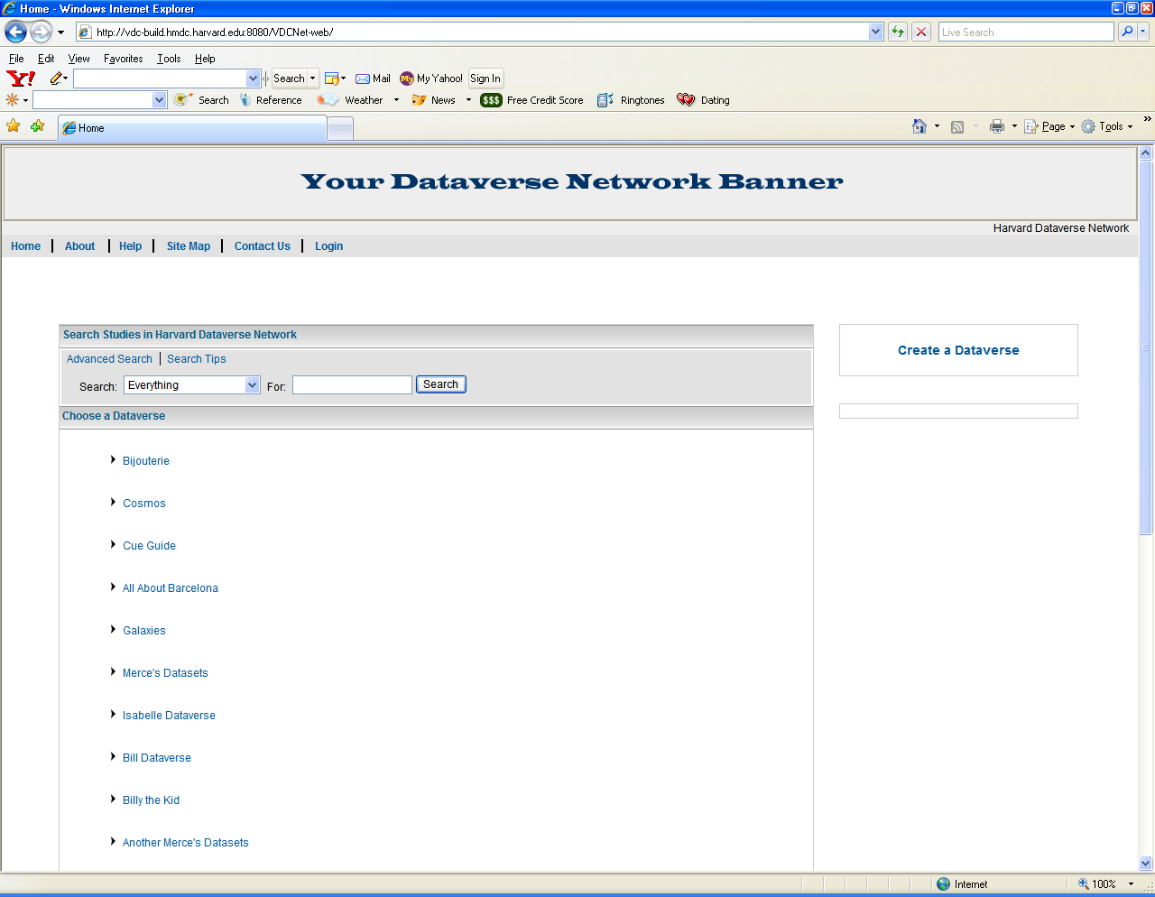

See next page..

2. Screen Capture - Enable Network Announcements is OFF (checked off) – Dataverse Homepage

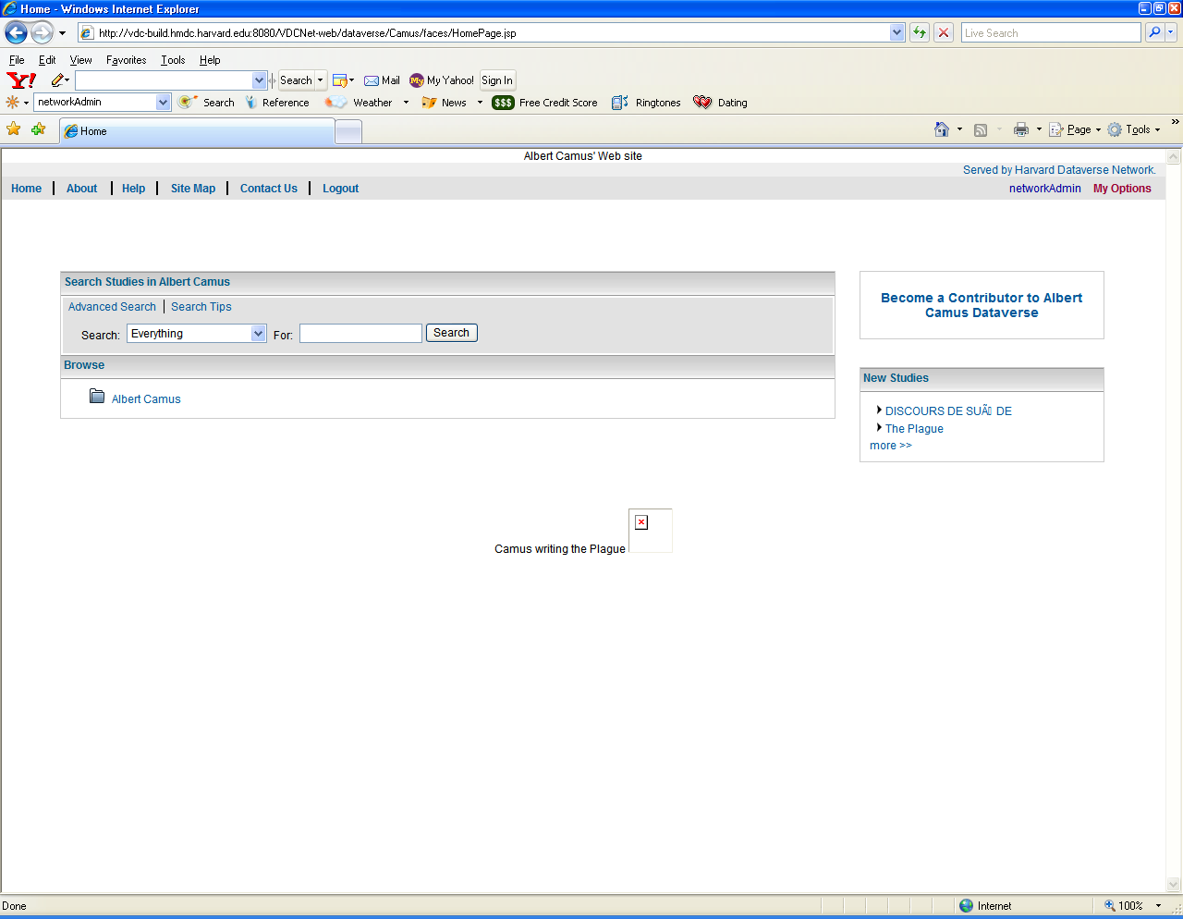

See next page..
- Screen Capture - Enable Network Announcements is ON (checked) – Network Homepage

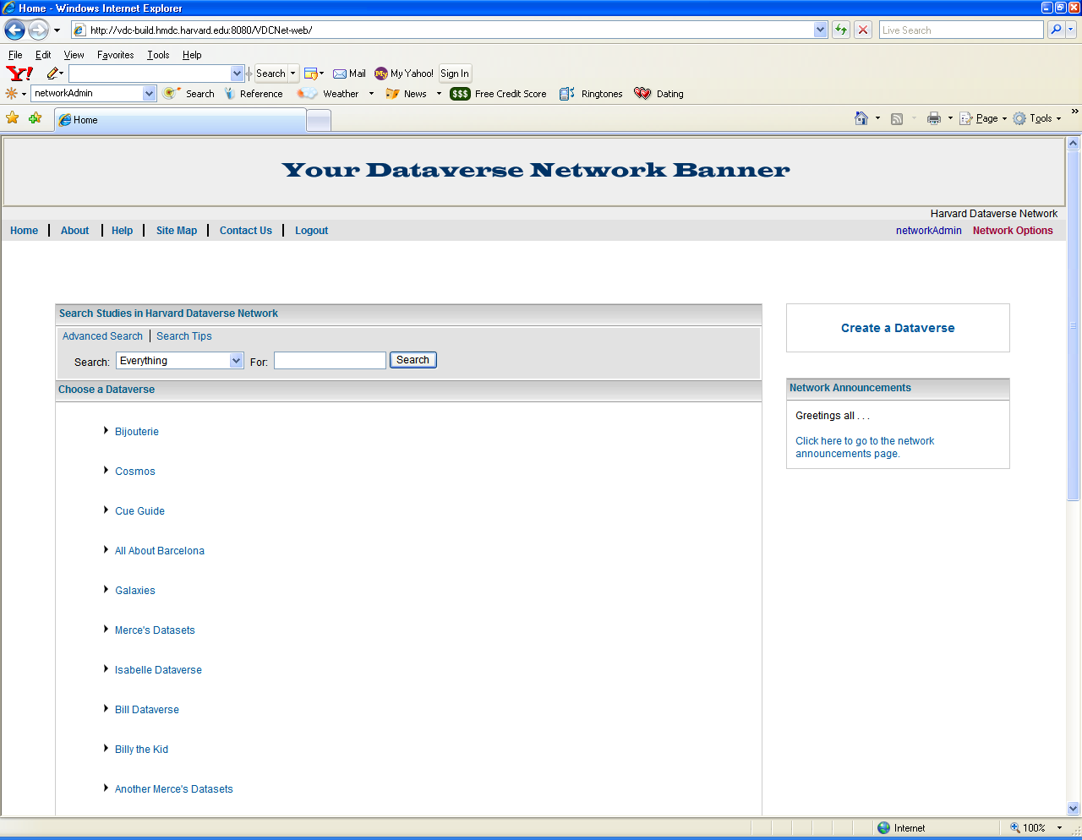

See next page..

4. Screen Capture - Enable Network Announcements is ON (checked) – Dataverse Homepage

